- Write in a standard form
  - $0.000 0056$ b. $71 300 000$

- Write as a number
  - $5.3×{10}^{5}$ b. $4.7×{10}^{-6}$
- Give your answers in standard form
$a. \left(3×{10}^{500}\right)×\left(2×{10}^{-400}\right)$ b. $\left(7×{10}^{-550}\right)÷\left(2×{10}^{-150}\right)$
- Give your answers in standard form
$a. \left(6×{10}^{-500}\right)+\left(8×{10}^{-501}\right)$ b. $\left(9×{10}^{402}\right)-\left(3×{10}^{400}\right)$
- Solve the following inequality and show the answers on a number line.
$5-2x≤19$
- Solve the following equations
- ${2x}^{2}+4=36$ b. $3\sqrt{x}-7=20$
- Add the following algebraic fractions
  - $\frac{x}{4}-\frac{2x+y}{3}+\frac{y}{6}$ b. $\frac{5}{a}-\frac{3}{3b}+\frac{7}{2ab}$
- Simplify the following algebraic fractions
  - $\frac{25xy}{12x^{2}}×\frac{3xy^{2}}{10x^{3}y}$ b. $\frac{4x^{2}}{15y}÷\frac{18x^{3}}{30xy}$
- Simplify the following algebraic fractions
  - $\frac{4x+2y}{6}$ b. $\frac{2x^{2}+x}{14x+7}$
- Find the equation of the line on the diagram below
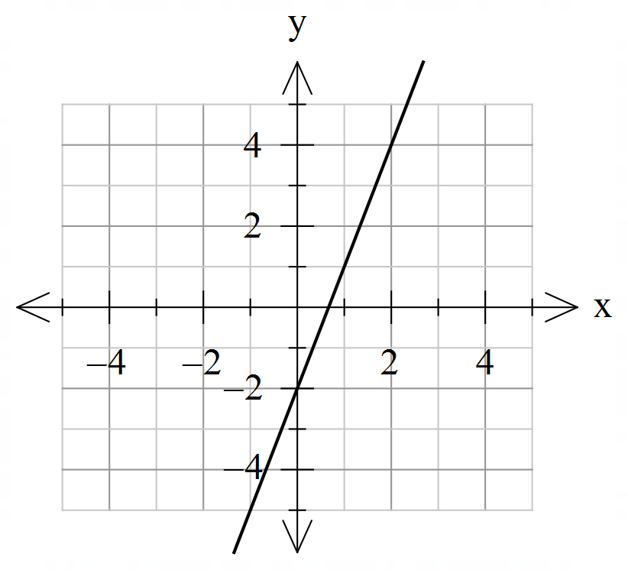
- Find the gradient of line passing through the points $(6, 8)$ and $\left(10, 24\right).$
- Find the gradient and $y-$intercept of the line $y=4x-7$.
- Find equation of line with gradient 5 and passing through point (3,20).
- a. Find the $x-$ and $y-$intercepts of line $4x+6y=12$.
b. Hence sketch the line.
- a. Draw lines $y=x+1$ and $y=2x-2$ on the same set of axes: 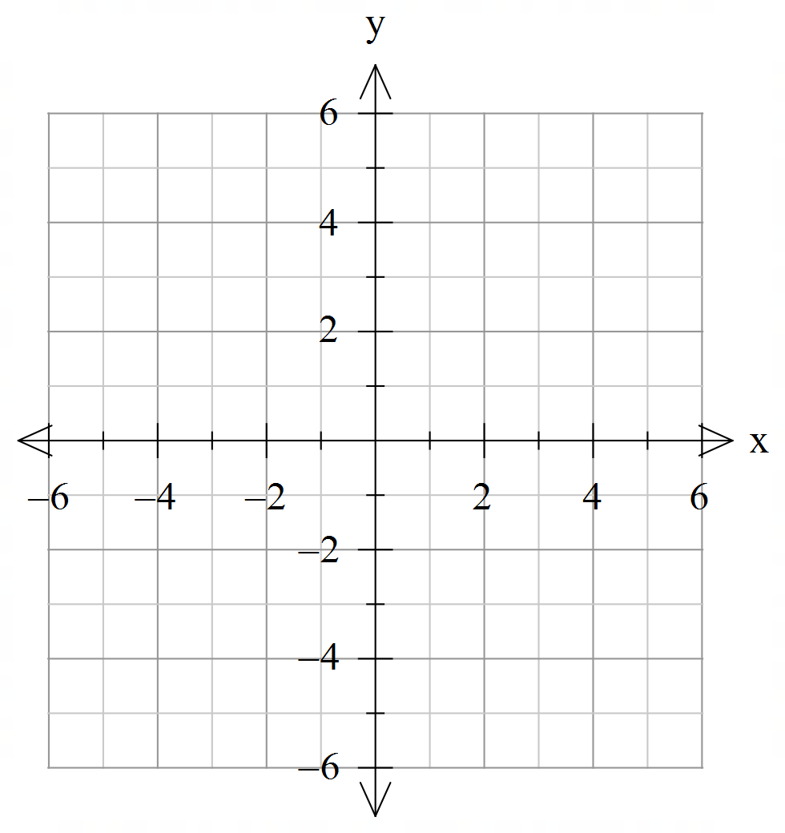
- Hence solve simultaneous equations graphically, using your graph.
$$y=x+1$$
$$y=2x-2$$
- Find the missing side length in the diagram.
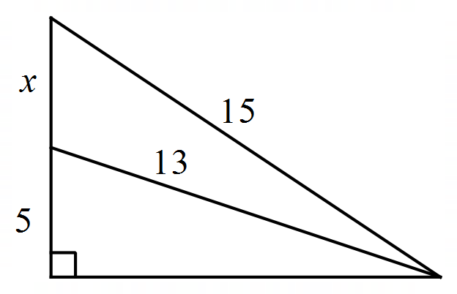

- Find the angle $x$, clearly state the reasoning.
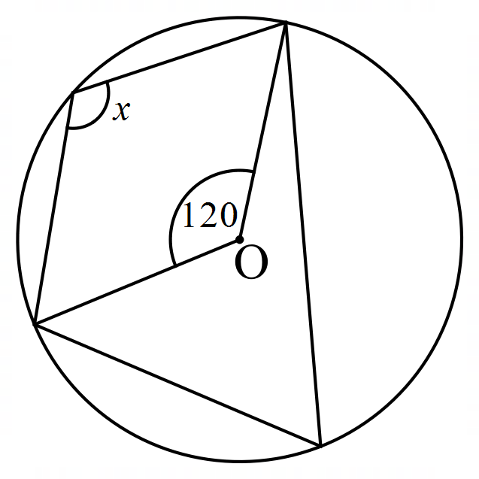
- Solve the following equations
  - $\frac{3x+2}{2}=\frac{4}{5}$ b. $\frac{2}{x}+\frac{5}{2x}=6$

